Motori elettrici applet e teoria BUONO

http://www.animations.physics.unsw.edu.au//jw/electricmotors.html#DCmotors Teoria e APPLET SUI MOTORI FATTA BENE
http://www.animations.physics.unsw.edu.au/downloads.htm#electric per caricare le animazioni di prima

Electric motors, generators, alternators and loudspeakers are explained using animations and schematics.
This is a resource page from Physclips, a multi-level multimedia introduction to physics (download the animations on this page).
- Schematics and operation of different types of motor
  - DC motors
  - Motors and generators
  - Alternators
  - Back emf
  - 'Universal' motors
  - Build a simple motor
  - AC motors (synchronous and stepper motors)
  - Induction motors
  - Squirrel cage motors
  - Three phase induction motors
  - Linear motors
  - Homopolar motors and generators (separate page).
- Loudspeakers
- Transformers
- AC vs DC generators
- Some web resources

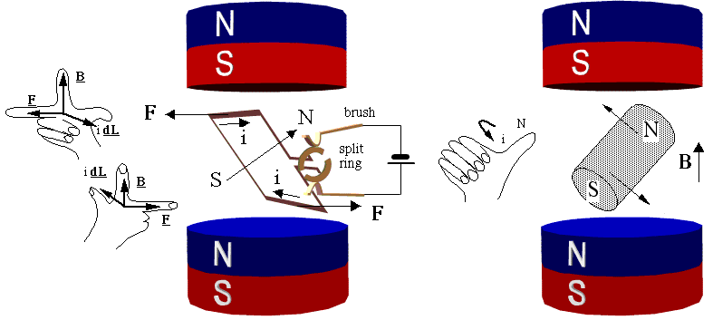

Physics animations and film clips.

Downloads for Electric motors and generators, Homopolare motors and generators and AC Circuits.
Downloads
Each of the mechanics modules has a multimedia tutorial with various support pages and each animation and film clip may be downloaded in zip files, either individually or in a single zip file for each module.
The animations are freely available for educational purposes. The links back to the Physclips Project on each resource must not be obscured. If you do decide to use any of the animations for teaching, we should appreciate being able to view the usage or any comments/suggestions on the usefulness or shortcomings of the resources (you can email us atJ.Wolfe@phys.unsw.edu.au).
Mechanics
- Constant Acceleration
- Projectiles
- Circular Motion
- Simple Harmonic Motion
- Newton's laws
- Weight & contact forces
- Work, Energy and Power
- Centre of mass
- Momentum
- Rotation
- Gravity
Electricity and Magnetism
- Electric motors and generators
- Homopolar motors and generators
- AC circuits

Electric motors and generators (related animations from Physclips)
- Download all electric motors animations (or individually below each thumbnail)
Download (.zip) | Download (.zip)
Download (.zip) | Download (.zip)
Download (.zip) | Download (.zip)
Download (.zip) | Download (.zip)
Download (.zip) | Download (.zip)
Homopolar motors and generators (related animations from Physclips)
- Download all Homopolar animations (or individually below each thumbnail)
Download (.zip) | Download (.zip)
Download (.zip) | Download (.zip)
Download (.zip) | Download (.zip)
Download (.zip)

AC circuits (related animations from Physclips)
- Download all AC circuits animations (or individually below each thumbnail)
Download (.zip) | Download (.zip)
Download (.zip) | Download (.zip) | Download (.zip)
Download (.zip) | Download (.zip)

