Sensore temperatura LM35 e Arduino con codice con Tinkercad
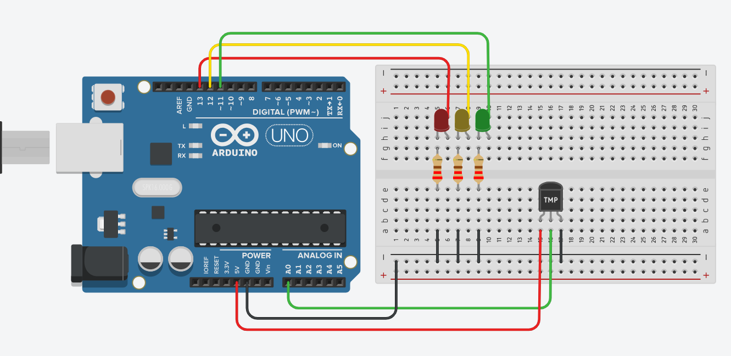

////sensor de temperatura usando o LM35
//
//const int LM35 = A0; //define o pino que lera a saida do LM35
//int temperatura; // variavel que armazenara a temperatura medida
//
////funcao que sera executada uma vez quando ligar ou resetar o arduino
//void setup()
//{
// Serial.begin(9600);//inicializa a comunicacao serial
//}
//
//void loop()
//{
//
// //getting the voltage reading from the temperature sensor
// int reading = analogRead(LM35);
//
// // converting that reading to voltage, for 3.3v arduino use 3.3
// float voltage = reading * 5.0;
// voltage /= 1024.0;
//
// // print out the voltage
// Serial.print(voltage); Serial.println(" volts");
//
// // now print out the temperature
// float temperatureC = (voltage - 0.5) * 100 ; //converting from 10 mv per degree wit 500 mV offset
// //to degrees ((voltage - 500mV) times 100)
// Serial.print(temperatureC); Serial.println(" degrees C");
//
// // now convert to Fahrenheit
// float temperatureF = (temperatureC * 9.0 / 5.0) + 32.0;
// Serial.print(temperatureF); Serial.println(" degrees F");
//
// delay(1000);
//}

//sensor de temperatura usando o LM35
#define ledRed 13
#define ledYellow 12
#define ledGreen 11

const int LM35 = A0; //define o pino que lera a saida do LM35
int temperatura; // variavel que armazenara a temperatura medida
//funcao que sera executada uma vez quando ligar ou resetar o arduino
void setup()
{
pinMode(ledRed, OUTPUT);
pinMode(ledYellow, OUTPUT);
pinMode(ledGreen, OUTPUT);
Serial.begin(9600);//inicializa a comunicacao serial
}
void loop()
{
temperatura = int((float(analogRead(LM35))*5/(1024.0))/0.01);
Serial.println(temperatura);
delay(2000);
if(temperatura<25){
digitalWrite(ledYellow, LOW);
digitalWrite(ledRed, LOW);
digitalWrite(ledGreen, HIGH);
} else if (temperatura <= 30 && temperatura >= 25){
digitalWrite(ledYellow, HIGH);
digitalWrite(ledRed, LOW);
digitalWrite(ledGreen, LOW);
} else if (temperatura>30){
digitalWrite(ledYellow, LOW);
digitalWrite(ledRed, HIGH);
digitalWrite(ledGreen, LOW);
}

}

