Prova N1 Tecnologie elettriche/elettroniche TEEA classe Prof. De Luca Fortunato (parallelo R)
COGNOME __________________ Nome ____________________ Data___________
Question 1 Identify which of these circuits is a parallel circuit (there may be more than one shown!):
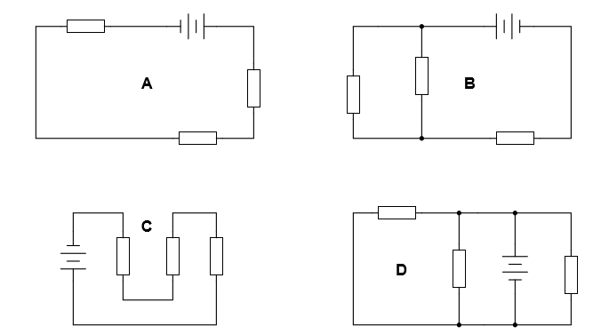
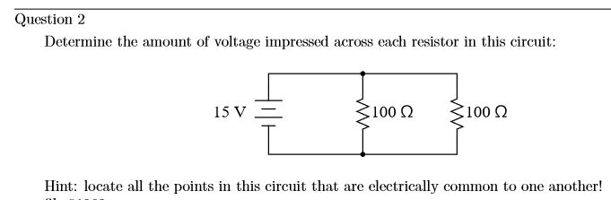

Question 3 According to Ohm’s Law, how much current goes through each of the two resistors in this circuit?
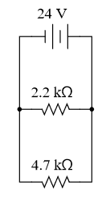
Draw the paths of all currents in this circuit.
Question 4
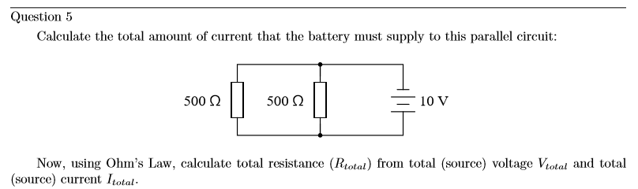

Question 6
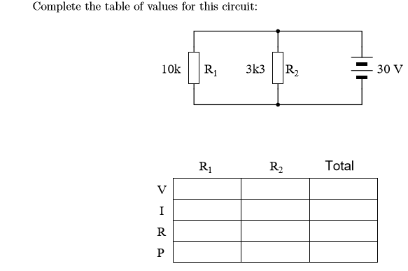
Question 7
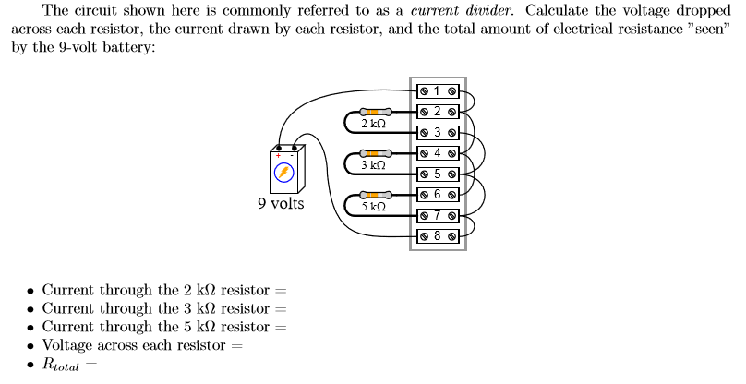
Question 8
